C. About USC, LDPI and Gnathology -
The Cross of Life and the Cross of Dentistry
from Dr. L. D. Pankey

I think that I found out that there was a cross that needed to be balanced. If you’re going to be an achiever, you are going to have your cross out of balance. But, you ought to realize that you cannot keep thinking that you can conquer everything by hard work and achievement. I think that the greatest thing I learned through that period of time was that I could become less effective and that the only way to get better was to let go. I think that has helped me relate to people professionally and personally. Those two words have helped me most with people that are high achievers and perfectionist. Let go.

As far as practice management is concerned, we wanted to bring Dutch Woehler, a practice administration consultant, to USC so the students could learn the business side of practice. At that time, the administration, wouldn’t allow us to do that at USC in the undergraduate program. So, we did the course at night in the library where I assisted him with his presentations and he offered consultations for the profession in the daytime.

One of the Dr. John “Dutch” Woehler study clubs, The Sanders Research Group, involved me with Dr. John A. Anderson who was a member. Dutch brought John to the `study group twice for a one-week continuum so they could study better dentistry after they had created more efficient offices. He told us, “It is imperative that you guys do better dentistry with the environments that you have created.” So we put on a couple of continuum programs for the study club. After that I met Niles Guichet at Dr. Woehler’s home and where he encouraged me to help place Dr. Guichet’s articulator in the school. John Anderson then introduced me to L. D. Pankey; Dutch Woehler had died and John had gone on to work with Dr. Pankey. It was through that introduction to Dr. Pankey and his invitation along with Dr. Loren Miller that I came to teach part-time at the L. D. Pankey Institute. Eventually, I was there full time. I was part-time in 72 and full-time in 74. It was time for a change in my life.

Ten years after graduation is when I started going to the Chicago Midwinter meeting every year. That was when I met Dr. Steve “Tap-Tap” Brown. Dr. Ernie Granger and Dr. Brown had mentioned to me that Dr. Brown would do a touch-up equilibration on the cases that Dr. Granger restored. I had an in-depth discussion with Dr. Granger concerning his articulator, what motivated him and the differences in the occlusion. Dr. Granger had an in-depth discussion with me on how, when people chew and they rub to and from their fossa, that they literally go down their working side, come into the centric area and then up the balancing side, a fully balanced occlusion near centric -- the centrum. That is the motion of how we chew and how we brux involving the balancing cusp. Balancing contact is a functional component of occlusion and relates to muscle and joint physiology. Balancing contact completes the “feel”, so to speak, of what you press, rub and go in and out of. Dr. Granger did not agree with taking the balancing side contacts out with a vengeance. He felt that left the patient “vacant”, with a different feel. He felt that his patients were more comfortable when there was a little bit of balancing side contact on the occlusal surface -- the other side of the centrum. He was not talking about a braced interference. He was talking about the balancing surface on the occlusal fossa that we call "centrum" which would function or fit. That is the way people come into your office, with them fitting, don’t they? That discussion with Dr. Granger gave me a lot of comfort. I found that people would be more comfortable if I didn’t change their occlusion too much.

The oral rehabilitation research program started by Dr. Ingraham at USC was a great learning experience. The technician controlled more of how the finished case looked than the articulator or the dentist. At that period in my life, Harold Eissmann was just graduating from dental school and came on the staff. He did a lot of the lab work for the “atlas” and teaching cases. I could see that his innate skill and learned concepts were projected into his beautiful dental anatomy. The resulting case was more a reflection of his skills and thoughts than anything else. He made his “vision” of the restorative case regardless of the records or articulators.

On the business side of dentistry, time and motion studies, work simplification and human factors gave me permission to work on the behavioral aspect of dental care. Then, knowledge of headaches and TMJ surfaced with my privilege of associating with Dr. Nathan Shore. I could recognize and simplify the mechanics and physiology of occlusion, while his role in educating the profession for the benefit of the patient shaped my viewpoint a great deal on the personalized approach to dental care. I was very impressed with how well he worked and his dedication to educating the profession for the benefit of the patient. He was just very open and very good at it.

Dr. Ramfjord influenced my understanding of muscles and TMJ with his work with the Michigan appliance. His concept of freedom in centric and the iatrogenic effects of dentistry influenced me greatly.

At this point in my life, I was impressed how dentists and the dental profession accepted the concept that headaches, TMJ, MPD, head and neck dysfunction were dental problems. To accept and advertise that dentistry is foundational in these problems has led many dentists to jump into diagnosing and treating all sorts of conditions. This is due to our desire to duplicate the experiences of our mentors. Since this is a dental perspective, they think of teeth, appliances and occlusion as the main agenda. Dentistry may be an involved part, but sound research and broad clinical experience reflect that these problems and issues require a multi-disciplinary approach.

Even though we are willing to do it, I am not sure that all dentists are very good candidates to treat these patients. In general, the personality attributes of most dentists and educational process in dental school makes them less capable of handling some of problems. The selection process for and training in dental school do not make them the best qualified from a temperamental or emotional aspect. I believe that there are a few dentists that are interested in these issues and adequately pursue them from a training and management perspective. They become effective, while most don’t. I am not so sure that MD’s are any better, since they don’t have the necessary dental background, temperament or the personal skills. Somewhere along the line there seems to be an “auto-selection” for the caregiver of excellence in these cases.

We all want a cookbook. If one thing will help most, it is a cookbook. That is why we are writing this book. The cookbook can get you started and, later, give broad guidelines. It can make some suggestions. Then, you have to do it yourself in cooperation with the patient.

Why not use a computer for diagnosis and treatment planning? There could be an expert program for treatment plans. There could be an expert program for diagnosis and treatment plans. Most of these flow charts are so complex that one can get lost in them, get lost from where one came from. By the time we find out where we are going we find ourselves in a maze, not amazement. Also, this kind of system may be a substitute for a strong doctor-patient relationship. It displaces the interview time in which we discover the patient’s personality traits. If there was an effective computer program, there would be reduced need to discuss this aspect of the problem with the patient. Give them a test and give them the result. No interaction in this significant area needing to be attended to by the doctor. It is more distant and remote. The capacity and time to interview and interact with the patient is one of the most important aspects of this process, and a cookbook can’t describe that. If a person (doctor) is not capable of eliciting the information in an interview, what are they going to do with the results when they come back in the mail? I would tend to believe that I wouldn’t want to tell them anything. If I don’t know what to do about it, why am I giving them information in the first place? Why even run an analysis, if I don’t know how to implement it? Most patients will be offended if the information is used to make a referral for self-help or counseling in the beginning unless the referral is done very skillfully. It depends on how comfortable we are with the patient and the test won’t help that. Some people are very comfortable, some never will be. The TMJ Scale test could be of help to show progress and to give some indication of the emotional aspect of the problem

The only cookbook that is useful is the one that we create for ourselves as a guide after we have learned our way into a process. It is our guide to our path. It is “routine” that we can reduce to paper the technique and process. Not something that we create and learn. We can share a compendium of experience that can shed light on the path and journey and some of the problems that we run into. We cannot create a path for anyone.

Finalization - How do you really finalize at case?
I think that it is open-ended. I know that most people, Dr.’s and patients want a quick fix. Therefore, they want a quick change with appliances, orthodontics, reconstruction and or surgery. But, I know that there is no quick fix. There are some people that will need these operative and/or surgical kinds of help, but very few. I think that almost every case is more simple than that. I think that there are a lot more questions than answers in this particular field. I think the answers are what we would like, but until we have handled the questions that come up, we are generally lost. I suggest that we can get most of our answers from our patients. They come in saying, “I’ve got TMJ”. I say, “I think that is wonderful, you have two knees and two TMJ’s. Not just one - two”. This response gives me an opportunity to relieve some tension and get going with, “What is it?” “Is it achy or is it noise? Is it the joint or is it muscle?” We have better newer diagnostic aids, but the treatment procedures are basically same. We have had some changes which have an impact of the result of care -- opening the bite, segmental appliances, orthodontics, orthognathic and joint surgery. All of these treatments make for changes, but as far as being valid treatment for an individual case, they may be questionable.

Opening the bite is not the issue, because there are very few closed bites. We restore generally to the vertical that the patient presents with. Segmental appliances change the bite and have caused more problems, I suppose, than anything else I see from appliance therapy. Orthodontic patients with four bicuspid extractions seem to have more MPD and TMJ problems than those treated without extraction. These cases often have a steeper anterior guidance (AG), the maxillary six anteriors are rotated and retruded, the patient ends up with an anterior Class II div 2 and a posterior Class I orthodontic occlusion; they feel very restrained and/or restricted.

I see a lot of orthodontics that is interrupted because of the need for appliance therapy during the treatment process. But, I don’t think orthodontics causes TMJ dysfunction particularly but MPD may be due to the emotional and physical stresses involved. Surgery is getting more conservative than ever. I think that after you diagnose and treatment plan from an occlusal perspective, the splint or occlusal appliance should be used first and its lessons learned. We will learn about Centric Relation Occlusion (CRO), freedom in CRO, CRO- Centric Occlusion (CO) shift or slide, the centrum area, CO or habitual occlusion, Anterior Guidance (AG), Incisal Guidance (IG), posterior disclusion, crossover interferences and patient compliance. All of these occlusal and behavioral dynamics can be learned better on an appliance than any other way. I have learned that second molar function differently during appliance therapy. We become more aware of the role the TMJ and muscle arrangement in relation to second molar function and change during appliance therapy. The physical changes in the restoration of second molars illustrate what I am talking about. We will see more changes in second molars than any other tooth during appliance therapy.

Migraines and arthritis - I find most migraine patients are more comfortable with appliance therapy; it helps reduce the side effects of the migraine. How the patients brace, hold and posture themselves is supported with the appliance. When they feel the migraine coming on, they put the appliance in and they are grateful, because it helps them cope with the pain and they have less severe side effects.

As far as arthritis is concerned, the appliance takes the pressure off the joint; there is less soreness within the joint and less muscle splinting.

Panoramic and transcranials - panoramic films will show you the head of the condyle very well and it should be used as a scanning film. Is there bone where bone is supposed to be? I appreciate transcranials; they gave me a comfortable feeling about the general position of the condyle in the fossa. I have seen repositioning in the fossa that could be related to appliance therapy.
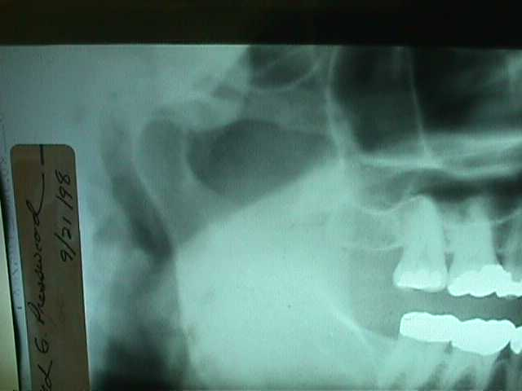
TM Joint display on panoramic x-ray film. All bony landmarks are visible

Internal derangement’s - mostly, I see laxity. I would say that the ones that are reciprocal clicks, middle or late, will rarely have much change in the noise with appliance therapy. They just become more comfortable. In a late reciprocal click with pain, arthrography will tell you what is going on, and an open surgical approach will fully disclose the problem. Most of the time, the surgery (arthroscopic or open) reveals unexpected adhesions, which are major contributing factors. That can explain why we don’t have success with our appliance therapy in these cases. Surgery to free the adhesions followed by occlusal appliance support can be very successful. In my experience, adhesions are frequently tenacious and in inaccessible areas requiring open surgery for correction. Arthrocentesis and/or arthroscopy are not effective in these cases.

HMT - The Long Buccal nerve courses between the heads of the External Pterygoid muscle and therefore can be squeezed, or compressed, when the muscle spasms which can result in buccal paresthesia.
Ringing in the ears, tinnitus, can be a result of muscle spasm. (Major Ash)

C. Diagnosis

1. Records - Dr. Tanner’s outline

Examination

How do they (the patient) feel?

Who -- are they? Tell me about yourself. Who have you seen in the past for examination, consultation or treatments?

What do they feel -- pain, ache, tight, stiff, click, pop, lock?

Where -- muscles, bones, joints, teeth?

When -- move, bite, chew, time, pattern?

How -- they feel, fit together, move?
If –you could have something happen right now, what would it be?
May I feel? - palpate their Joints, head and neck, function and/or tenderness.
May I feel your muscles as they clench your teeth together? Where were the tender spots?
What are you doing with your teeth as you are clenching and pushing the muscles against my fingers?
How do they fit when you touch, tap or clench?
May I watch as you bite and rub around and then slide left and right and forward?
May I feel your jaw rotate in the socket?
1. Relax your cheek muscles, throat muscles and chin muscles.
2. Now let your jaw drop down and back.
3. Now feel your jaw rotate in the socket.
4. Can you feel a tooth touching? Which one - back, front left or right?
5. Does it make any difference if I hold your jaw with two hands or one hand?
6. Can you now do it yourself, without me holding your jaw?

May I watch it?
1. Rotate your jaw.
2. Touch the same tooth and
3. Hold still on that tooth.
4. Then press on it, and
5. Then clench hard.

What did you feel happened in your mouth?
How did your teeth finally fit together?
Are there back teeth on one side that don’t touch?
Do the front teeth move when you clench?
Bite on cotton rolls - Molars, bicuspids, front teeth.
We have observed what you have and what you can do with what you have.
Which is more important?
How you got it? -- Why is it that way?
What would you like to be?
What would be better, could tolerate, would accept?

The purpose of an Appliance (removable splint) is to: diagnose and treat, maintain support, provide relaxation and rest, and (provide) a change when needed.

Diagnosis
Tell the patient the following:
“To use scientific methods we need to take impressions of your teeth and recordings of your joints and muscles. Then we can mount your casts on an instrument that will accurately duplicate how your jaws and teeth function. To be thorough, we would also suggest obtaining radiographs of your teeth, jaws and joints.
An appliance (removable splint) will accurately diagnose the relationships between symptoms and your teeth, muscles and joints.

We can determine how your jaw rotates in the socket today and in the future, as changes occur, we can make further comparisons.”

Treatment Features/Experiences -

Reversible - if the appliance does not work, it can be removed and the patient goes back to their natural teeth

Occlusion 90% - in most cases of head and neck pain, occlusion plays an important part and if we manage the issue properly there will be an impact on the discomfort you feel.

Equilibration necessary - if the appliance proves that there is an occlusal component to the pain, spot equilibration of some teeth might be necessary.

Finalization - in some instances, detailed equilibration, orthodontic treatment and/or complex restorative dental treatment can be required.

Long-term stabilization - the dynamics of dental occlusal issues requires continuing observation and correction in some cases which, in effect, are never finished but can be maintained in stable function with commitment and effort.

Minutia must be observed and eliminated so that it does not trigger or bother. We will refine the appliance to remove minute areas of interference that cause discomfort, bother or that trigger other responses.

Feel the same The intent of the treatment is for you to feel the same with appliance or touching your own teeth.
Appliance—can be used as a night guard, during stressful times, or as a security blanket

OBJECT OF TREATMENT: A Journey from awareness and perception of minutia toward occlusal perfection, less awareness, less discomfort, and feeling less bothered.
- Note: The functional characteristics of the appliance, -- the front teeth don’t touch, so it is easy to feel all of the back teeth touch at the same time. Because the back teeth are not steep, they don’t feel “locked in place”. It is easy to touch, press, and rub around on them without feeling the front teeth. When pressing towards the front teeth, the pressure on the back teeth is released. It will be possible to slide on the front teeth as far as the jaw can move on all directions (right, left and protrusive crossover), and the back teeth do not touch.

A proper diagnosis is the most helpful thing. So, we have an initial visit, take a good history and perform a thorough examination, which may lead to a good diagnosis. Then our treatment is more appropriate, and that is what we are really after. We are so over-trained on treatment that we tend to fall into “solving” too quickly. Solving is our comfort zone and with the speed with which we frequently think, we may reach an incorrect conclusion. There is one thing for sure, it may be inappropriate to jump in at our usual rate. Failure is almost always guaranteed when we act too quickly.

In Diagnosis, we are going to be dealing with records of all kinds, mounting the case in the lab, analyzing the records and then coming back and verifying our diagnosis with an appliance. So, I think that there are very important paper forms for patients to fill out and give to us at the interview. Much of this can be done at our convenience and comfort; before, during or after the initial interview. If we are going to get down to what “IT” is, I think that we need to get personally involved with the patient, and to write down what they are feeling, and what suggestions they have. This involvement is the basis for this particular regimen, process, cookbook or outline.

Because I tend to deal with feelings, they are the interesting aspects of the interview for me. I created the question list because I am interested in the who, what, where, when, why, how, and if. I learned to be aware and open at Dave Hoffman’s workshops. What “IT IS” and what they are really doing with “IT”, their habitual pattern, is what I am after. This is a scientific method and in problem solving it helped me understand how they “Do IT?” and “What IT Is.”. Reference - Marvin Mundel – Motion and Time Study – What, Where, When, Who, How, Why, So What?

I am interested in what patients feel. Is it an ache, tight, pain, stiff, click, pop? Although these are my points of interest, I don’t ask the patient about all of them. I know that if I ask them, “What Is It?”, somewhere along the line they will tell me what I want to know. If I ask them, “Where Is It?”, they will usually point to it. “I have TMJ, I’ve got it bad.” “Well, point to where it is” (points to the
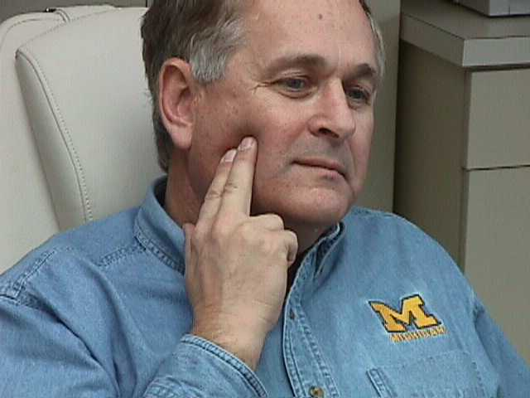
Patient complaining of ‘TMJ’ points to the Masseter muscle when asked to locate the pain and point to the area.

Masseter muscle). They will not only tell me the name to the best of their knowledge, they will tell me how worried they are “about it” in the way they say it. They will point to it. Usually it will be muscles, bones, joints and teeth. And “When do they have it?”, “It is when I move, bite, chew”. “What time of the day, how long does it last, what is the pattern?” If they tell me all of this and I understand “What it is”, then I say, “When is it?” and “How often is it?” and “I know that they are the ones that have it.” That takes care of the “Who?”. If necessary, I might say that they left something out. Something is missing, how about this? But I usually do not interrupt them. I usually want them to go through that whole process so that we will get to the “How?” -- How teeth fit together, how teeth move and how jaws move.

I am trying to draw them out on a feeling level on each of these issues and the last question is, and obviously they don’t know, “Why?” But I am still going to ask them, “Why do you think things changed the way they have? Why are you aware of this?” Then, if they can get into the “why”, they will probably get to point out, “Well, somebody hurt me, something caused it, or I don’t know what caused it”. “Could it be heredity?” If it is heredity, then, they can get their anger and frustration out because they know who to blame and most people want to blame somebody else. If it is that kind of a thing, then I just let them blame their mother and/or father, if they know for sure. If not the parents, it has to be their grandparents, so let’s go get one of them. After they get all of that out, they can laugh about it and then realize that they can’t do anything about that aspect of the problem. So, I really do want them to realize that most of our characteristics come from heredity whether it is our temperament, our personality, what we are doing with what we’ve got and all of that. “Because, if it really is inherited, then let’s accept ourselves for what we are and get on with it. Let go and get on with life.”

Then I ask them some more things about feelings. I just go down the outline and say, “Well, may I feel that joint, or that muscle, or may I look at this? I don’t want to hurt you, would you like to point to it? Will you, then, let me feel it?” And the way that I can feel if it is muscle related is, “If you will put your teeth together where they fit and clench on them. Keep them together now, don’t open and close, just keep them together and pump, pump, pump, so that you are flexing your muscles against my fingers. Would you push your muscles against my fingers?” That is when I will do the three parts of the temporal and four parts of the masseter.

If they feel their teeth and clench on them, whenever they clench, I will touch the muscles and watch my fingers move. I can feel whether the muscle contracts. I can watch which side is bigger. I can feel the firing sequence. I can see what works, see what hurts and which teeth are involved. Then, when I have enough information, I can ask them, “Do you remember any of those spots that were sore when you pressed your muscles against my fingers?”.
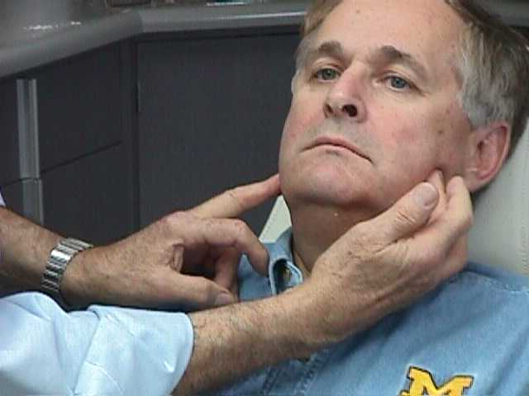
Having the patient press against your finger as you touch different areas.

When they press against my fingers, they won’t hurt themselves. But they will do a good job because they want to participate and help you find the trouble at this point. So they will endure a little bit of discomfort by doing this, but it is not like me doing it to them when they are unaware. That can hurt and it catches them off guard and puts them “on guard” against future discomfort and pain. They don’t like it when they get hurt. They didn’t come in for that. They came in to get to feel better. But people with sore spots and lameness will press against my fingers even though it may be uncomfortable, because they are in control.

If they say they don’t remember which muscle hurts, ask, “Well then did any of them hurt? Was it left or right? Can we go back and find it out? Would it feel comfortable to allow me to feel again while you press against my fingers?” “Sure!” So, then, I will do it again, not over the joint but on the muscles. If there is tenderness when I put my fingers in their ears, then it is probably in the joint. If it is front of the joint, then it is probably the muscles and we find that out more clearly when we feel the muscles. If we feel the posterior border of the masseter, we can be over the area of the external pterygoid. We don’t have to reach into an inaccessible, tender part of the mouth to feel that muscle. If it is painful, then I say, “Let’s go over it again”. Then, I touch and let them identify the tender and sore spots. They will report, “This one, that one” and so on. Then we know which spots are tender.

Outline -
Muscle Palpation - Push on my fingers – The Routine.
- Muscle Function
- Muscle discomfort
- Minds-eye on the teeth - relationship of tooth contact to muscle tenderness. “What are you doing with the teeth?
- What is the difference of fit? Right to left? Front to back? Temporal Headache, Sinus Pain, Tooth Pain, Face pain.
- Face Pain - Clenching on space, whole muscle aches. If pumping on a tooth, specific area is tender. Outside of condyle is tender, Deep Masseter or External Pterygoid might be affected.

And then I ask, “Put your mind’s eye on the top of your teeth. Do you feel what you are doing with your teeth when these muscles are tender?” “What do you perceive about your teeth when you are clenching and pushing against my fingers?” “I don’t know”. “Well, I know you can if you just relax and put your mind’s eye up on top of your teeth. You just squeeze, squeeze, squeeze.” Then touch the muscle that is affected and you will probably find that it is related to a tooth contact. If it is a masseter, it is because one side fits and the other side doesn’t and they pump and clench to get them together. They may be overworking the muscle that will help them understand fatigue and “Charlie-horse”. They can feel front to back as well and side to side and they can get a relationship with the teeth and muscles. Front of the muscle pressing toward the front teeth, back of muscle pressing toward the back teeth and the side of the muscle when locking, splinting and pressing. This process sorts these issues out very easily.

This allows me to get comfortable with them and their chief complaint, even though they did not have the slightest idea when they came in. The more relationships that you can gather, the more reasonable it becomes, you see, and the more relaxed they become. As they become more relaxed, they begin sharing more things with us that they don’t normally think are related or important. Things they weren’t even going to tell you about themselves. So you are just improving their relaxation and comfort zone all the way along the line. That is why I have been really grateful to let them do it; show me what they are doing and even where what muscles are tender. I don’t have to reach inside their mouth. If there is nothing outside to feel, I will sometimes put a mouth mirror in the mouth behind the tuberosity and palpate from the outside (skin) to test the external pterygoid. We don’t reach for the muscle in that tender area with the end of a finger. If it is the internal pterygoid, it is the easiest thing in the world to touch, but I don’t do that because it usually hurts to touch and they jump. I don’t do that because I would rather them know that if the masseter is tender, so also will be the internal pterygoid, depending on which way they are shifting and clenching and bracing. Because so much of the cause of the pain is muscles, I do this examination first. I have felt the joint and the muscles and the way they clench. I can then ask them, “How do you like the fit of your teeth? When you touch them, tap on ‘em, clench on ‘em?” They then know the difference between those three exercises.

Before I go into the mouth and get “tooth-centered”, as a dentist would normally do, I prefer to stay out of the mouth as long as I can. I want to build a relationship before going into the mouth. So that is why I say, “Well, now that I have felt some areas, you have shared with me what you are doing with your muscles and you have also found out what you are doing with your teeth, may I watch as you bite on your teeth and slide around on them?” I watch them bite and then I watch them slide; slide over to here, a little bit more. I am actually checking the anterior relationship when they bite and as they slide left and right. I can see whether they quiver, whether they press and don’t move, whether they relax and gradually slide down on the teeth. I can watch as they go out toward an incisal edge and avoid it or go to an edge that is comfortable where they have done all of their bruxing and created all of those perfect wear areas. I’ll have them go beyond that as far as they can and then if the front teeth open up, I will know that they have a molar touching in the back. I will ask them, “Is there something in the way that keeps your teeth apart like that?” So they can have working or balancing interferences when they go into crossover positions. Essentially I am asking them to bite, press, slide around, as far as they can go, so I can watch what happens.

Then, we are interested in how the jaw rotates in the socket. We have gotten to understand how they clench, press and rub on their teeth. So, still asking permission, because they have already found out that they can tap-tap on it, they can press on it, they can rub and clench on it, “May I feel how your jaw rotates in the socket?” “The jaw rotates in the socket, there is a center of rotation, I can feel the center of rotation, you can show it to me, may I feel it?” I think that to feel the rotation, we should use Dr. Pete Dawson’s two-hand manipulation. I don’t do it with force. I do place my thumbs together and I put my fingers under the border of the mandible, because I would like to feel how it rotates. As I begin, I will put the back of my hands on each side of their face and say, “Just relax your neck, relax your face, your throat and your chin, drop your jaw back”. That’s when I have my thumbs in place and then I feel them drop into centric position. Then - “Tap, Tap”. After that initial experience, you can switch to one hand or no hands and get the same feeling and the same tooth contact on “Tap, Tap”.
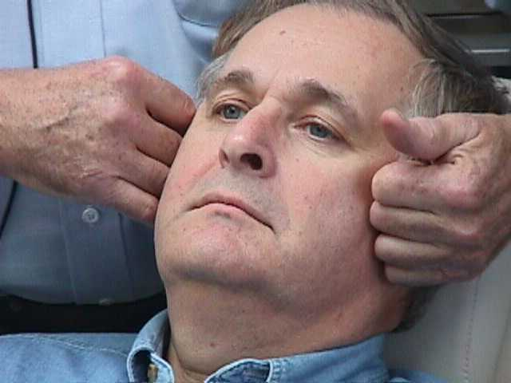
Use the backs of the hands to rock the head left and right to loosen the neck prior to asking the patient to open and tap their teeth.

I have felt the rotation of the mandible, is the main thing. Now it is time to say, “It is OK to let your teeth touch and to feel them touch. Go ahead, just let whatever touches, can you tell what it is? Back, front, left or right? Well, that is OK. Just take your time. Which one is the one that you feel?” The minute that they say, “Yes, I can feel that same tooth touches every time” and the jaw is relaxed, I say, “Would there be any difference with two hands, one hand or no hands?” “NO! There is no difference, I can do it by myself?” “Yes!”

The reason that I like them to be able to do it by themselves is because I would like to watch it. So I say, “May I watch you do that? The only way I can watch it is if I put my finger in your mouth and pull your cheek out and see.” They have identified which tooth it is, I might as well look at the tooth they feel, touch it, then press on it. So I don’t have them bite on it, I would rather have them touch it and put pressure on it, a little more pressure on it, then they slide and we can identify which tooth we are talking about.

We can put dimension to the motion of the tooth that touches and how the jaw slides when pressure is put on the teeth. They do not change once they have felt it. If I can do it with two hands, one hand and no hands, they can touch and repeat the same thing for me as I watch. Then, if I watch from in front of the patient, I can see the deviation left and right.

Then I just start asking more questions. “What did you feel happen in you mouth? How did your teeth finally fit together? Are the back teeth on one side touching more than the other side?” I already know the answers because they have told me, but I want to confirm that the situation has not changed in the course of our examination. “Do your front teeth move when you clench on your back teeth?” “I don’t know.” “Well, put your finger on here (touch an incisor tooth) to see if it moves.” “Yeah, they really do, it does or whatever”.

Then, to continue the differential diagnosis, I would pick up some cotton rolls and have them bite on them, one on each side. “Bite on the molars, bite on the bicuspids and bite on the front.” I say that when they are biting, chewing and putting forces in those places. This process may elicit some discomforts, signs or symptoms. So I am building relationships to be able to know how they bite on which teeth. Because they might bite straight or they may bite left and right on a cotton roll. If the jaw joint hurts when they bite, because it is sore within the joint, when you put a cotton roll between the front teeth, it hurts even more. If it is the external pterygoid, because they are pressing towards their front teeth, it hurts in front of the ear, because the external pterygoid is pulling left and right or both together. So you can begin to sort out some of these issues.

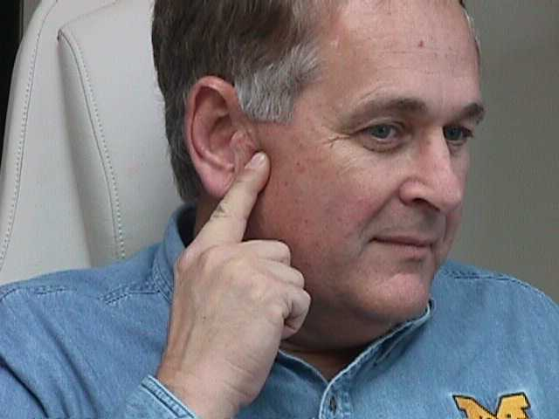
‘Point to the area that is uncomfortable’. Here the indication could be the deep masseter or the TM Joint.

“Now that we have done all of these, what else?” “Well, we observed what you have.” “We have observed what you do with it.” “So, what you do with what you have has been observed.” “Let’s make an evaluation. What really is more important? What you have or what you are doing with what you have?”

In the back of my mind, I know that it is easier to change teeth than people. Therefore, I am trying to bring them into something that I am more familiar with. “OK!!! Now, all we have to deal with is how you got it? Why are you this way? What would you like to be, what would be better, what could you tolerate, what would be acceptable?” And they will get right into the act and be helpful. “Well, what would you suggest? How do you do all of this? What is the relationship?” “When we get down to that, there is an appliance, a removable splint, a night guard, whatever you want to call it. The appliance can assist in diagnosis, be used in treatment, help maintain support, provide relaxation and rest and permit changes when needed because of the flatter occlusal table.”

If the dialogue is comfortable and there is a correlation with words used, then I think that they can say, “All right, I think I would like that.” So, that is when I am through with the examination phase. Basically, that is the way the process goes in a cookbook, linear fashion. In real life, the path is not linear but we will cover all of the bases if we take the necessary time. They will give us everything we want, in time.

We have a written medical and dental history form because we want to draw out all of these points during the interview. We will cover all of the muscles, joints and movements; find the tooth relationships and contacts. We will find limitations of movements and restrictions of muscles or joint. If we have them open wide and then we can “bounce” them into a further range of motion, we know that the restriction is muscles, not joint adhesion. We know, because we can talk them into relaxing more. “Just relax and open gently” and they will open wider -- limited by muscles. If the masseter is restricting, spray and stretch will help along with “bouncing”. If the lateral motion is restricted, the external pterygoid might not be contracting all the way, which often changes immediately or overnight with an appliance. We have smoothed the movement out and unlocked them. These steps are diagnostic and quick. The diagnostic outline is in the back of the book.

We have been discussing muscle physiology and I think everyone should have a copy of Travell and Simon’s book (Myofascial Pain and Dysfunction, The Trigger Point Manual, William’s and Wilkins, 1983), read and be familiar with it. In this day and age, a general practitioner should know the basics of muscle function and physiology. We owe that much to ourselves and our patients. It should be in the corner library for the patient to be able to see the muscle outline in color and then they can have a clearer idea of the problem. They can see the word, how to spell it, what it means, and that it is valid. Then I will say, “Why am I interested in the first contact? - Because there is a compensation that has to take place. The jaw doesn’t stay on its rotating axis when you touch a prematurity and then slide to where all of the teeth fit. You either have to accommodate and miss it all of the time, or you have to slide on it all of the time and either of these actions can cause muscle fatigue and pain. So then you switch and miss it and go straight to maximal contact. So then, there must be different muscle tensions to keep the jaw forward and balance the system.” The external pterygoids have to work and the anterior portion of the internal pterygoid, temporalis and masseter have to overwork. Using the book, we can show the patient that the external pterygoids work with protrusive and left and right excursions. They are related with these movements as well as maximal opening. Then we realize that within the head, behind the eye, in front of the ear and in the throat, there are muscles that can fatigue and cause referred pain from over work supporting the occlusion.

When they are trying to get out of a tight occlusion by clenching and rubbing, the temporalis, masseter and the internal pterygoid muscles are overworked. However, most people relate better to the two pairs of outside muscles.

We are also interested in the first contact and excursions for verification of the records and mounts that we have made of the diagnostic models. If we say, “This is a scientific method of taking impressions and recordings to mount your models on an instrument, then will be the same as it is in the mouth. With this accurate set of records, we can make something that will feel like new set of lower teeth to you. It is a removable appliance that allows all of the back teeth to touch at the same time; that will give the occlusal characteristics that help most people. If it helps you in these ways, we can actually identify and begin the diagnosis of the problem. And if things do change, we can later compare the center of rotation and how it has actually physically changed. We also experience a relief in symptoms and we know that it is all related.” By reviewing the parts of the muscles that are affected, it helps them relate to “it is what I am doing with my teeth”.
a) Chart – Ronald C. Auvenshine, Henry M. Tanner, Parker E. Mahan

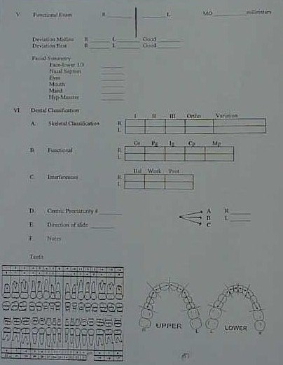
Auvenshine Chart
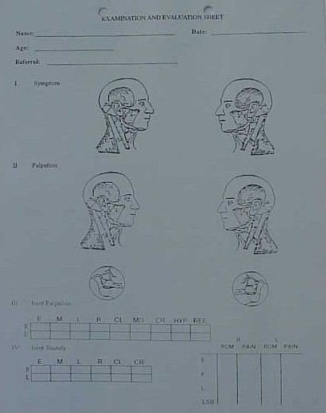

Auvenshine Chart

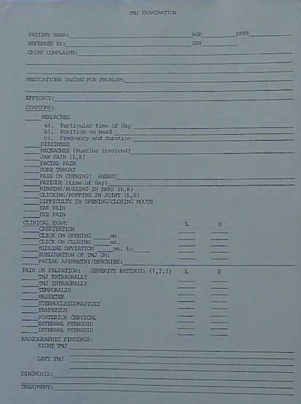

Tanner Chart
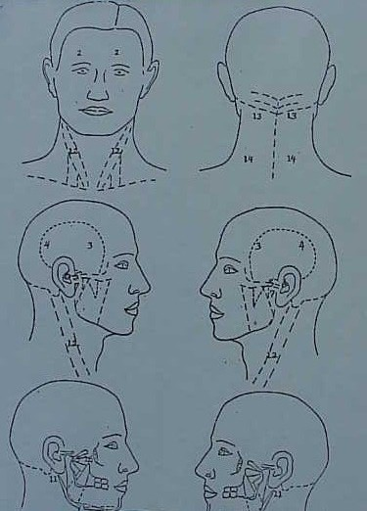

Tanner Chart

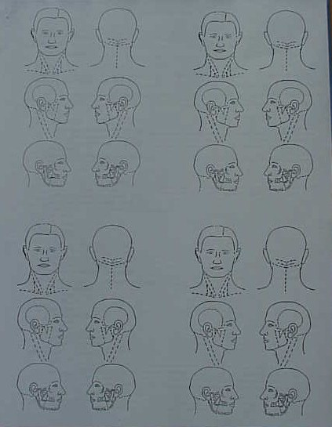

Tanner Recall Chart
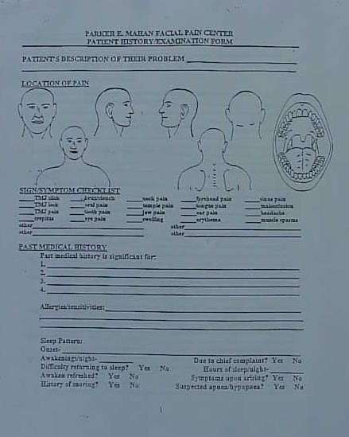

Mahan Facial Pain Center Chart

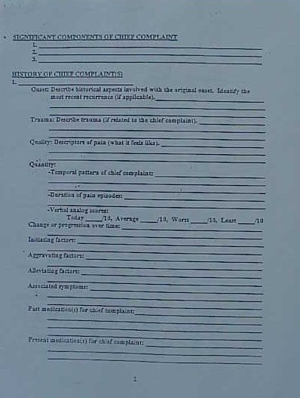

Mahan Facial Pain Center Chart
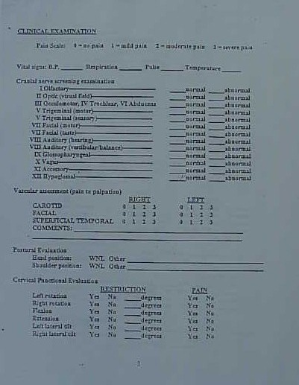

Mahan Facial Pain Center Chart
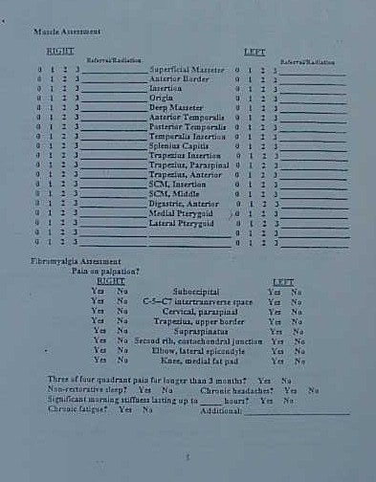

Mahan Facial Pain Center Chart
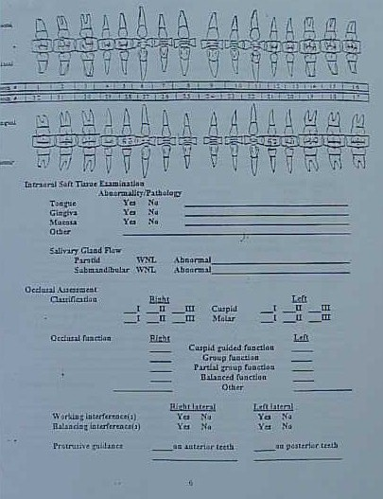

Mahan Facial Pain Center Chart
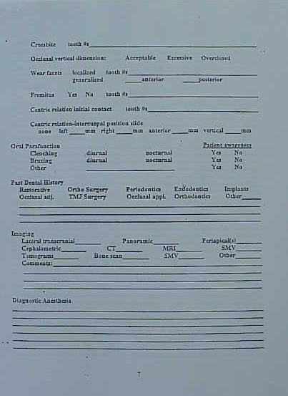

Mahan Facial Pain Center Chart
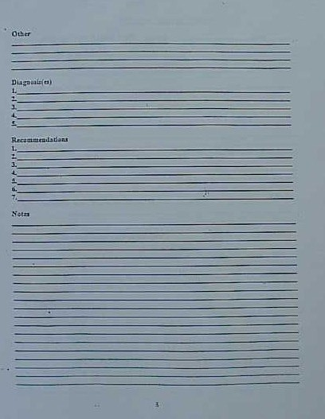

Mahan Facial Pain Center Chart
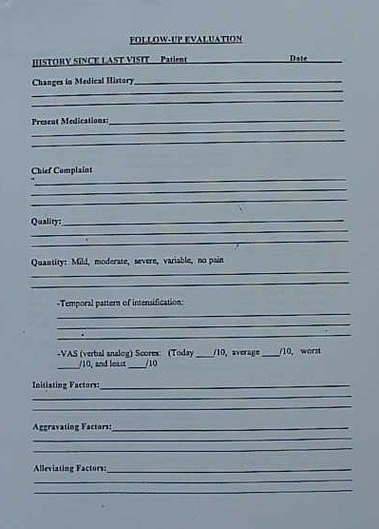

Mahan Facial Pain Center Follow-Up Chart
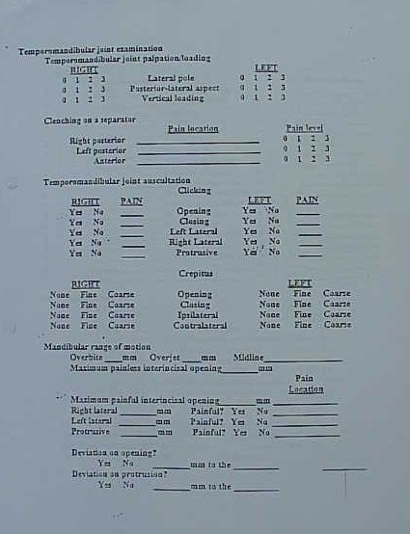

Mahan Facial Pain Center Follow-Up Chart

